Angular Routing- Students Handout

Workshop 1
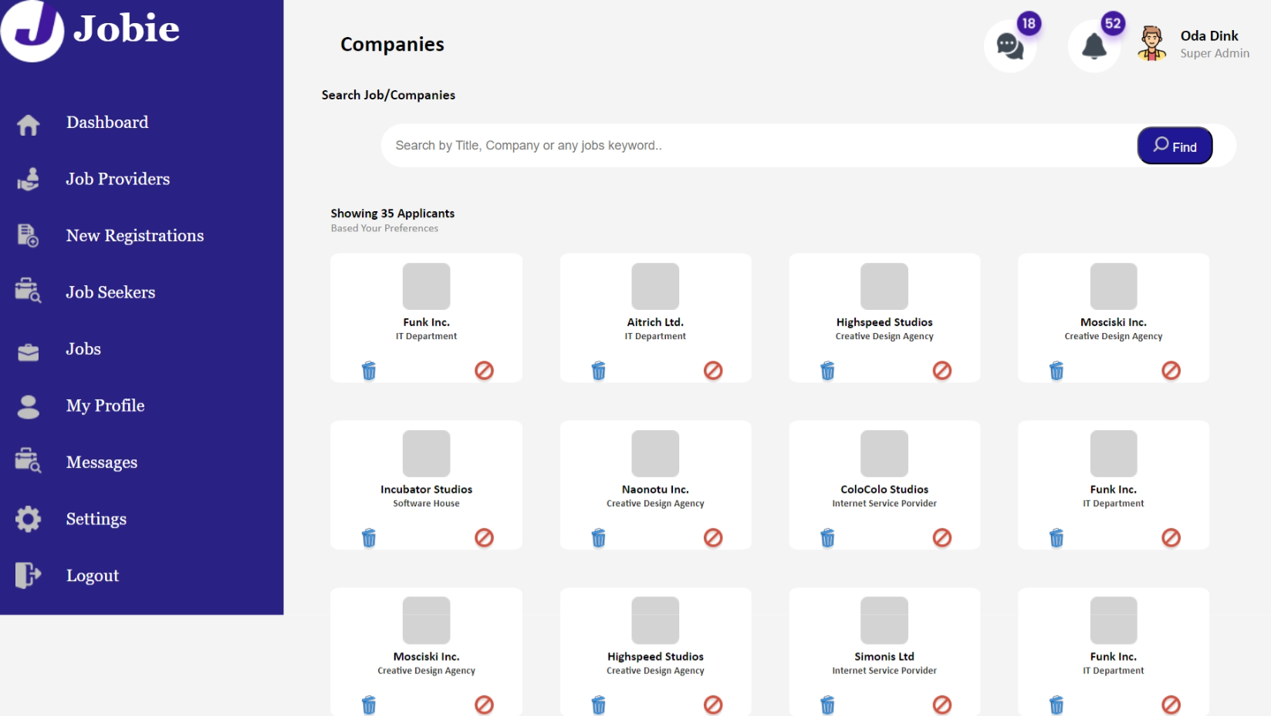
- Add routing to New Registrations and show the page like SPA.

Expected Output
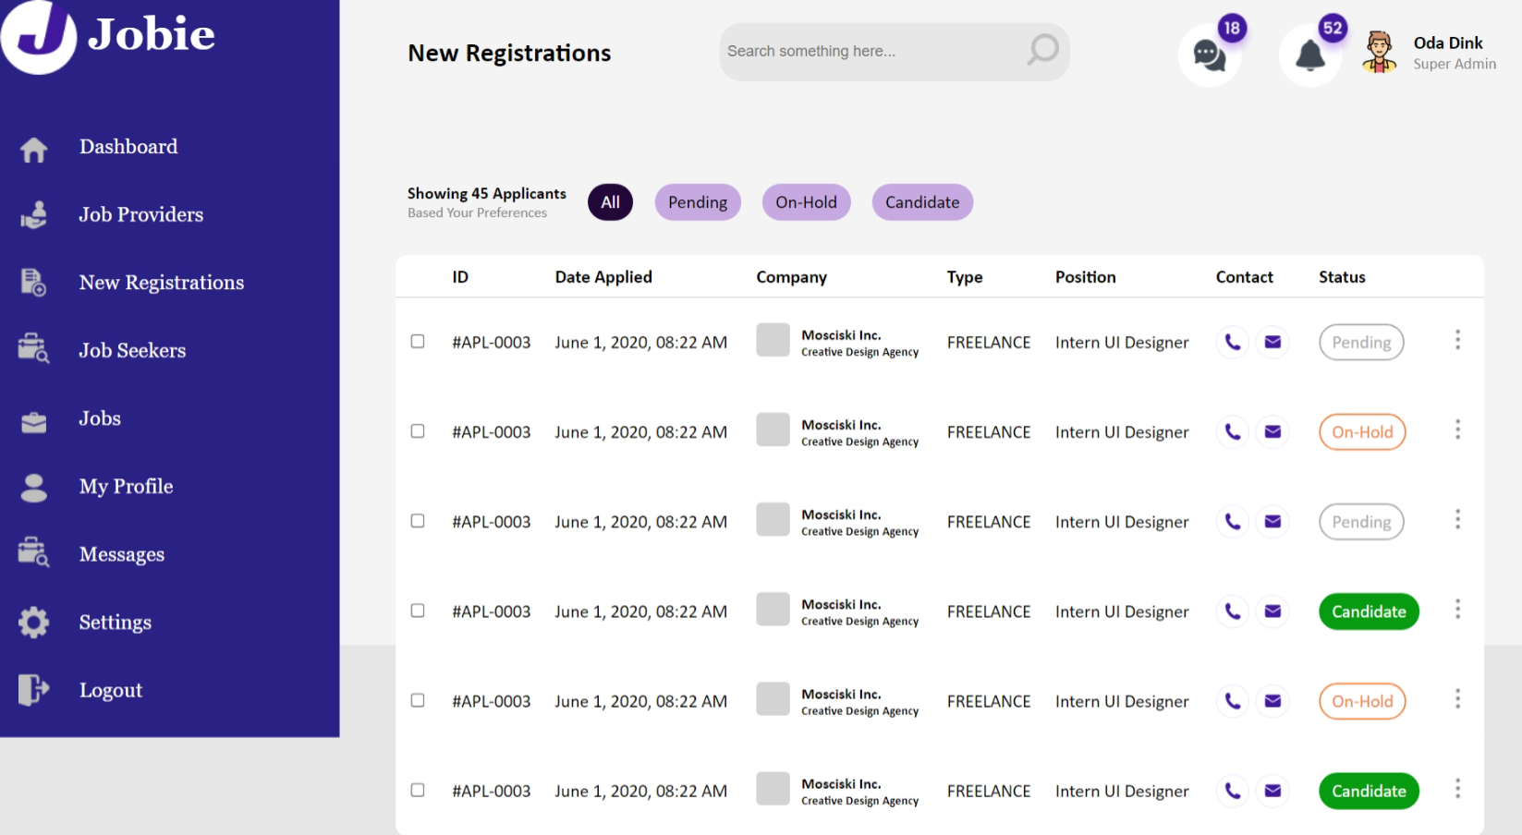
Workshop-2
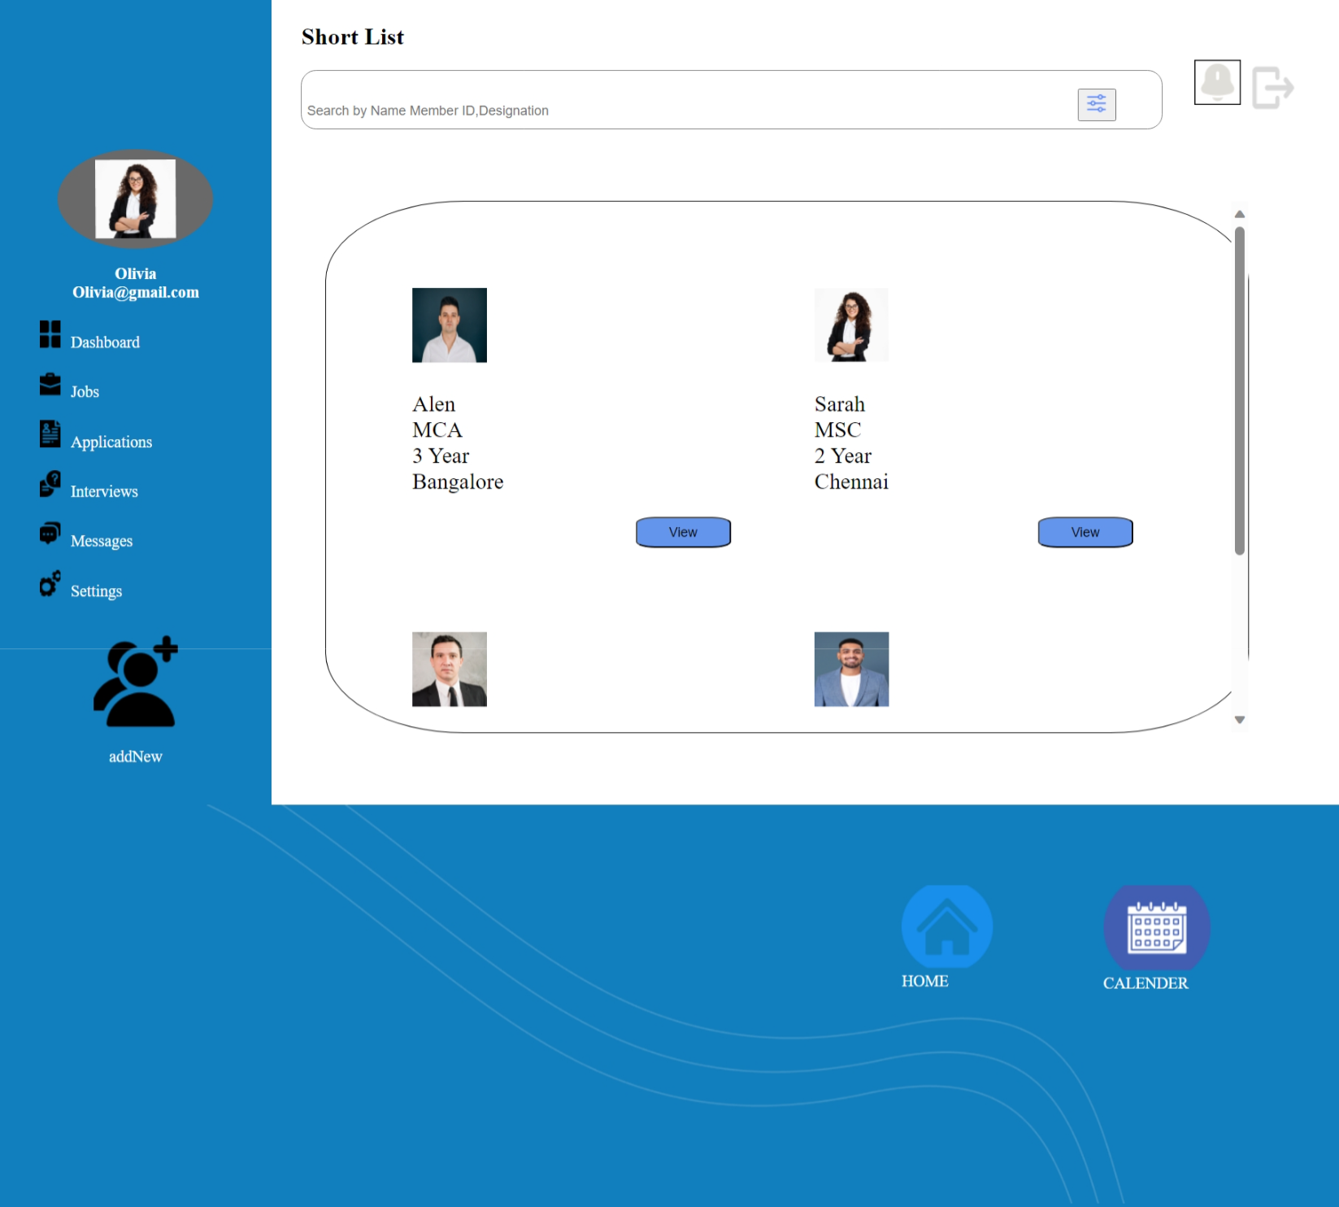
- Add routing to Jobs and show the page like SPA.
Expected Output
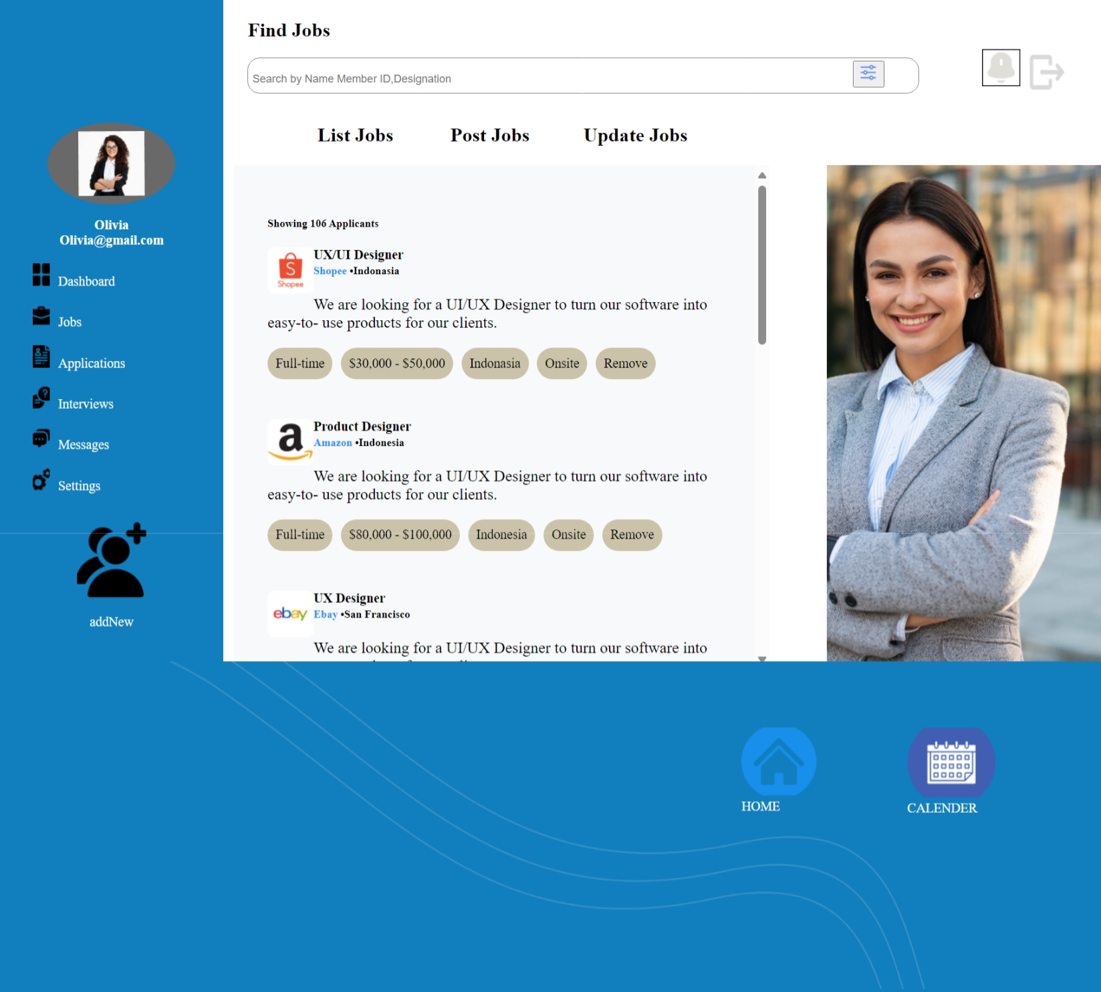

Workshop 3
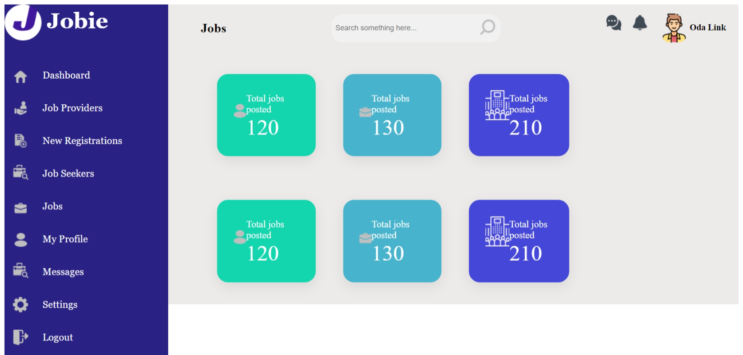
- Add routing to Jobs and show the page like SPA.

Expected Output
